*** ***

***Software Design Document***

***(SDD)***

***Project Title:*** Khan Products (Product Selling Website)

***Author*:**  Abdul Ghafoor

***Roll No* :**  F22BINFT1M01208

***Section* :**  M5(7th)

***Supervisor*:** Dr. Musrat Karim

***Date*:**  January 2026

***1. Introduction***

* ***1.1 Purpose:***

*This document provides a detailed technical design for the "Khan Products" website, mapping the requirements from the SRS to specific software modules and database structures.*

* ***1.2 Design Scope:***

*Covers the architectural design, database schema, and detailed module logic for the User and Admin panels.*

***2. System Architecture***

* ***2.1 Architectural Style:***

*A* ***3-Tier Architecture*** *will be used:*

* + ***Presentation Tier (Frontend):***

*Developed with HTML5, CSS3, and JavaScript (using XAMPP for local hosting).*

* + ***Logic Tier (Backend):***

*PHP 8 for server-side processing, authentication, and session management.*

* + ***Data Tier (Database):***

*MySQL to store data for users, products, categories, and orders.*

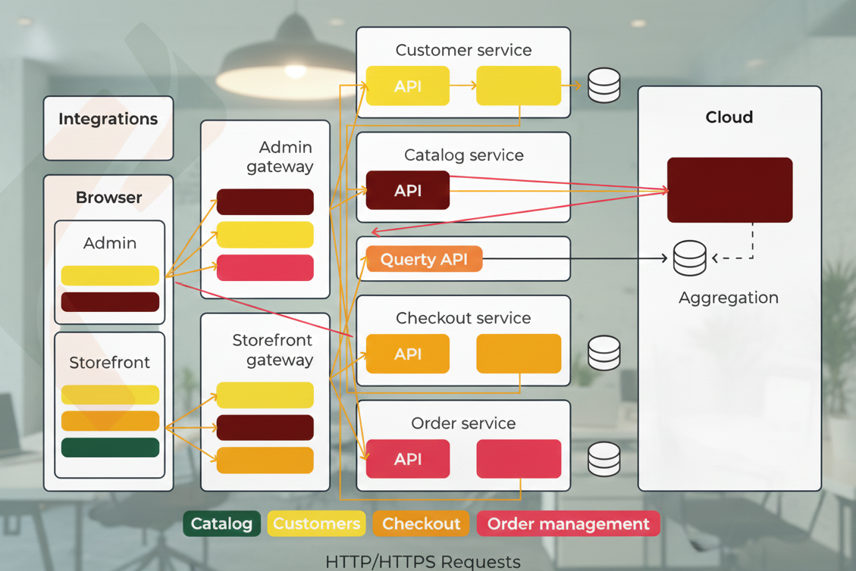

***3. Database Design (Data Design)***

*Based on your SRS, the MySQL database will include the following tables:*

* ***Users Table:***
* *user_id (PK),*
* *name,*
* *email,*
* *password (hashed),*
* *role (Admin/User).*
* ***Products Table:***
* *product_id (PK),*
* *name,*
* *description,*
* *price,*
* *image_url,*
* *category_id (FK).*
* ***Categories Table:***
* *category_id (PK),*
* *category_name.*
* ***Orders Table:*** *order_id (PK), user_id (FK), total_amount, status (Pending/Completed), date.*
* ***Order_Items Table:***
* *item_id (PK),*
* *order_id (FK),*
* *product_id (FK),*
* *quantity, price.*

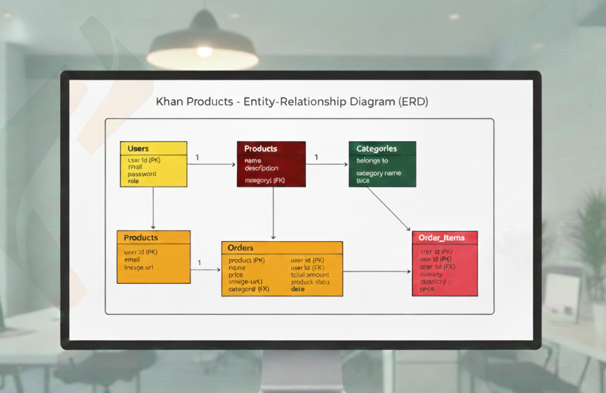

***4. Detailed Component Design***

***4.1 User Module Logic***

* ***Registration/Login:***

*Implementation of PHP sessions (session_start()) and password hashing using password_hash() for security.*

* ***Shopping Cart:***

*A logic flow where products are added to an array (stored in a session or database) before being converted into an Order.*

***4.2 Admin Module Logic***

* ***CRUD Operations:***

*PHP scripts to* ***C****reate,* ***R****ead,* ***U****pdate, and* ***D****elete products and categories.*

* ***Order Management:***

*An interface for admins to view user orders and update their delivery status.*

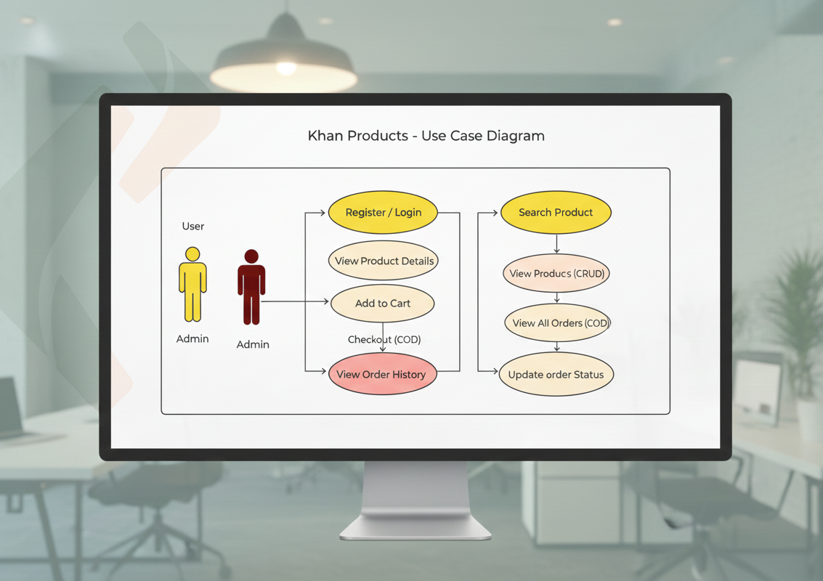

***5. User Interface (UI) Design***

* ***5.1 Design Principles:***

*The UI will be responsive (using CSS Media Queries) to ensure it works on both desktop and mobile devices.*

* ***5.2 Key Screens:***
  + ***Home Page:***

*Featuring a search bar, navigation header, and product listing.*

* + ***Product Details:***

*High-quality images and detailed descriptions.*

* + ***Checkout:***

*A secure form for confirming Cash on Delivery (COD) orders.*

* + ***Admin Dashboard:***

*A sidebar-based layout with tables for managing inventory and users.*

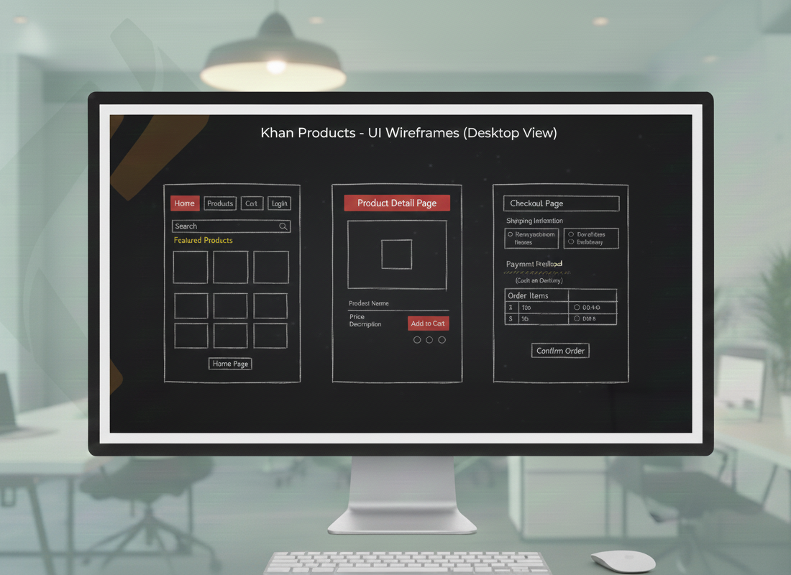

***6. Security and Environment***

* ***6.1 Development Tools:***

*VS Code for coding and XAMPP (Apache + MySQL) for the local environment.*

* ***6.2 Security Measures:***

*SQL injection prevention using Prepared Statements in PHP, and data validation/sanitization for all user inputs.*

